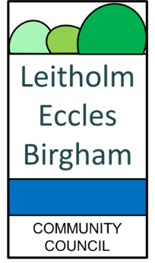
RURAL SCOTLAND’S COMMUNITY COUNCILS

“Together to stand up for Communities impacted by Major Energy Infrastructure across Scotland .”

To: Community Councils, Perth and Kinross Council

As you know, the speed of renewable energy infrastructure developments has gathered pace, with many of us being under considerable pressure to respond to complex and lengthy renewables applications, with many ultimately being approved by the Energy Consents Unit or Scottish Ministers.
The speed of transformational change is enormous. It is more important now, than ever before, that our impacted communities come together and try to speak with a combined voice on behalf of those who are being adversely impacted. This stronger, combined community-based voice should seek a place at the top table when decisions are made regarding our landscape, way of life and heritage.
Some of us know of people who are moving away from impacted areas or who are seeing a reduction in the value of their homes and businesses, not to mention health and wellbeing impacts. That needs to be recognised and addressed at the top table.
Over the past 10 months a series of Community Council Conventions have been held across the country to highlight the impact on communities of major energy infrastructure projects. The events have collectively been attended by 176 community councils. Irrespective as to whether these have been in the Highland Region, Aberdeenshire or across the South of Scotland the message has been the same:

- Our communities understand the need to transition from fossil fuels and the need for each community to play its’ part.
- The totally unplanned approach to the process has allowed developers, grid operators supported by the Scottish Government to ride roughshod over our communities with total disregard for their views and total disregard for our rural heritage.
- Communities are clear, the Transition is being done to us, not with us.
- This has led to the industrialisation of rural Scotland far beyond what is required for the transition.
- The impact on our people is profound: from health and welfare, to livelihood to the loss of a rural way of life.

Community Councils who have attended these Conventions have agreed the Unified Statement originally created by Councillor Helen Crawford, Highlands Council:

Unified Statement:

That our Community Councils:
- RECOGNISE the impact of Climate Change on our planet but OPPOSES an unjust an unnecessary industrialisation of Rural Scotland.
- CALLS for our elected members to URGENTLY support and protect our communities at NATIONAL level, given that community consultation is inadequate and LOCAL DEMOCRACY is being overridden, with decisions made by Community Councils and Local Authorities consistently disregarded by the Scottish Government.
- CALLS upon the Scottish Government to undertake a PLANNING INQUIRY COMMISSION to address the whole cumulative impact of all major renewable infrastructure developments, including transmission, storage and generation with all ancillary infrastructure on our communities and landscape, rather than the salami sliced approach which has thus far been taken.
- CALLS for a PAUSE of all major applications, given the impact upon our communities, which may hasten depopulation in some areas until a clear NATIONAL ENERGY POLICY is in place and an ECONOMIC IMPACT ASSESSMENT undertaken given that tourism is a major part of our rural economy.
At this time we are reaching out to Rural Communities across Scotland asking that they consider the outcomes of our three Conventions and to support the Unified Statement to bring about some order to the chaos and vandalism being caused to our people and Environment.
Please place this subject on the Agenda of your next Community Council meeting for consideration and advise us of your position.
Should you wish further information, or to reply with your response, please email leitholmecclesbirghamcc@gmail.com

Yours faithfully,

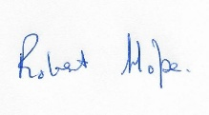
Chair, Leitholm, Eccles and Birgham Community Council,
Berwickshire

